EXPERIMENT:23

Design DFA using simulator to accept the string the end with ab over set {a,b)

W= aaabab

AIM: To Design DFA using simulator to accept the string the end with ab over set {a,b)

W= aaabab

INPUT:

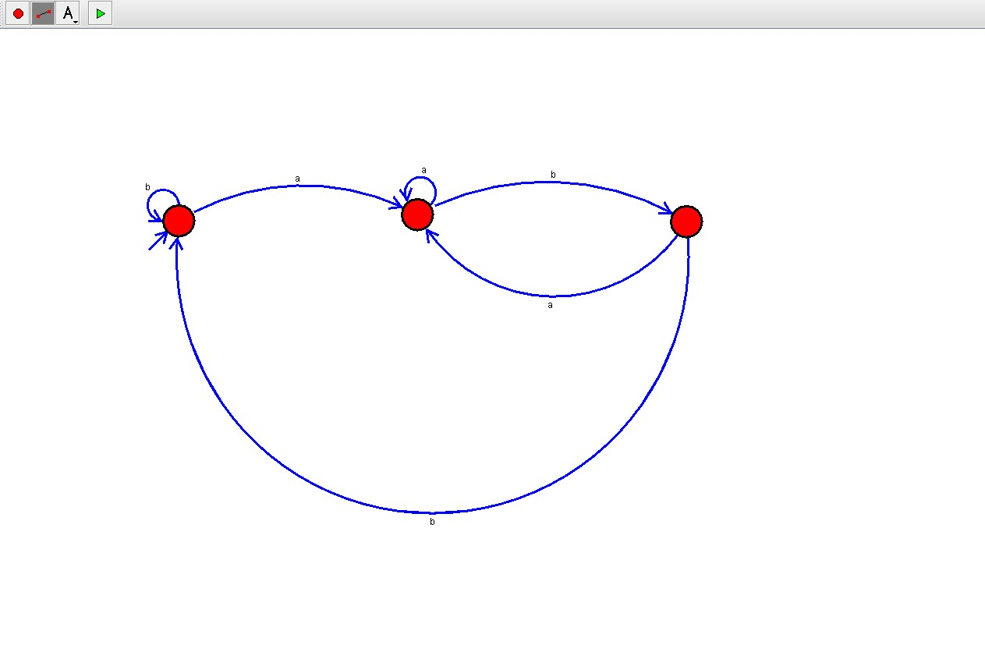

OUTPUT:

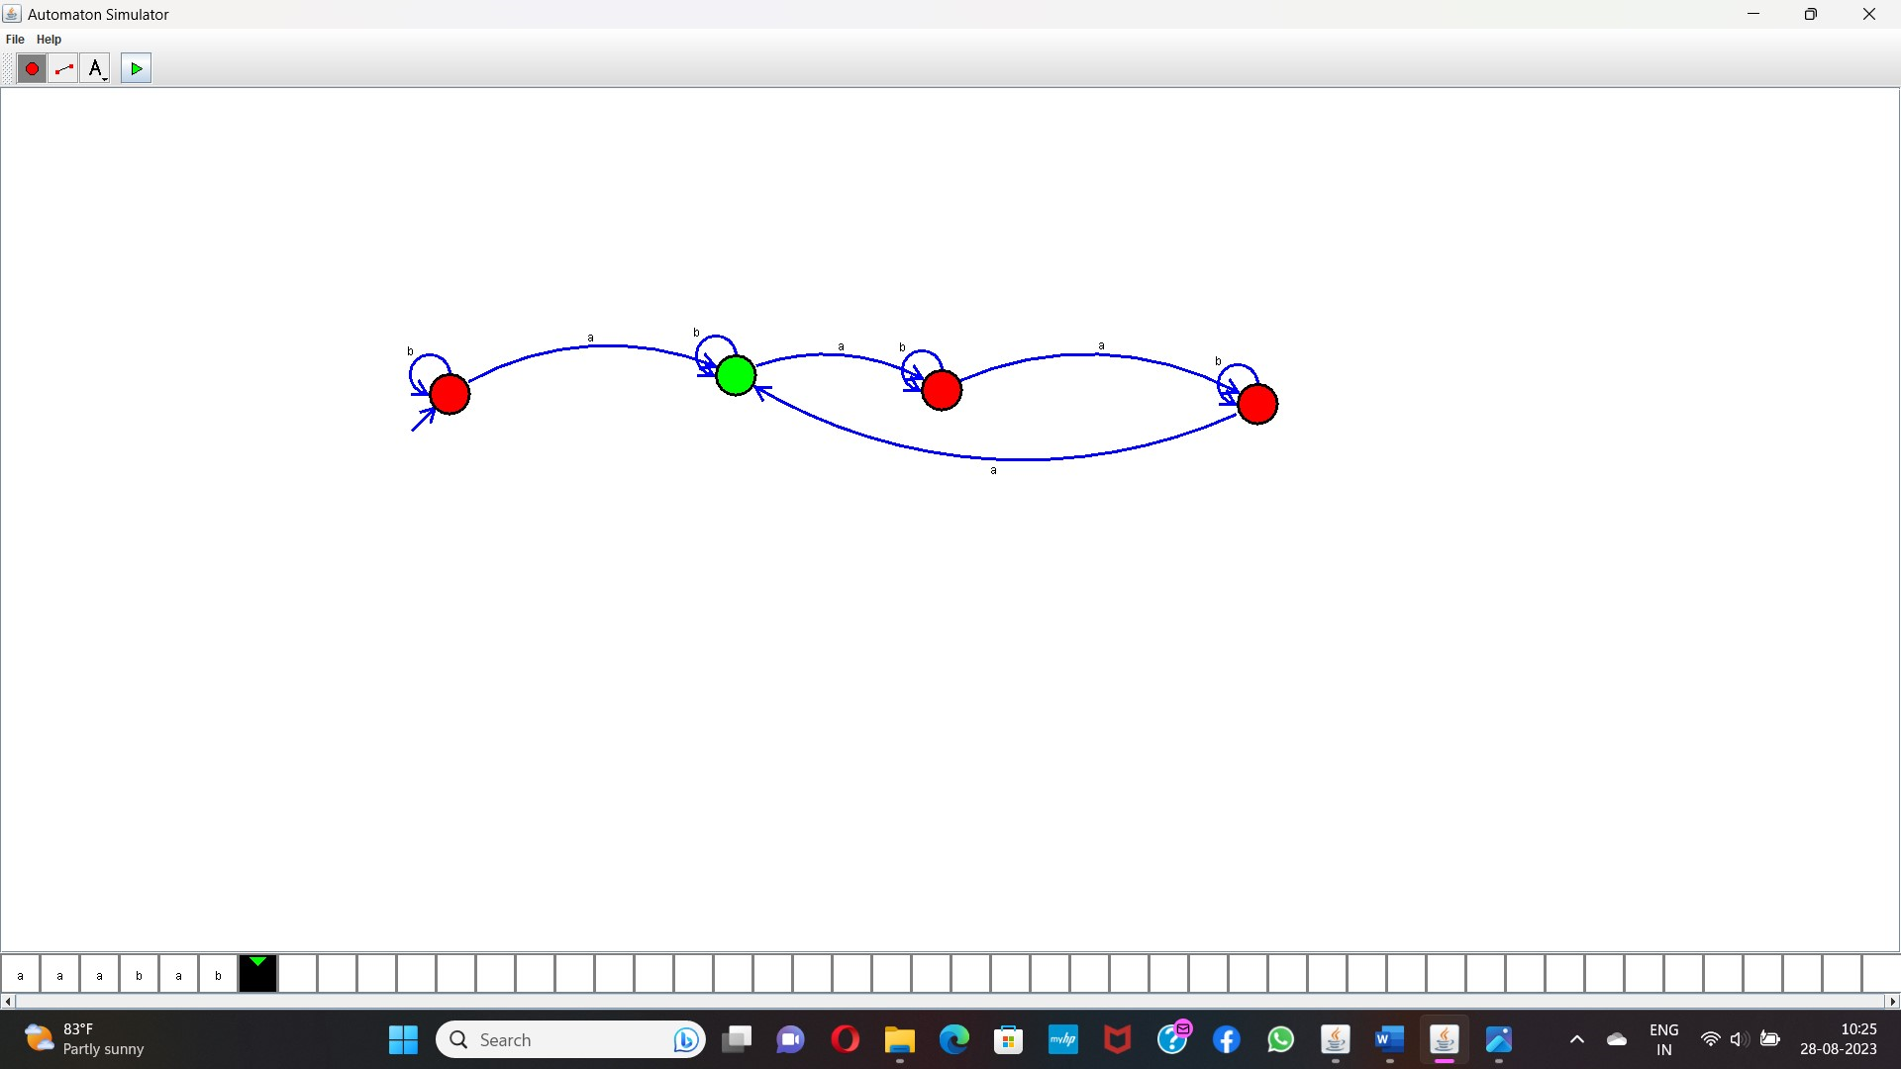

RESULT:

The program executed successfully and got output.